EchoClean: A Real-Time Intelligent Toxic Speech Detection and Filtering System for Voice Chats
Yash Gupta, Vikas, and Ojasvi Tanwar
Maharaja Surajmal Institute of Technology, New Delhi, India
Under the mentorship of Mr Ravi Choudhary and Mrs Neeti Sangwan

ABSTRACT

The expansion of real-time voice communication platforms—such as multiplayer games, virtual collaboration tools, and social audio networks—has introduced significant challenges related to harassment, hate speech, and toxic interactions. Unlike text-based communication, spoken communication is spontaneous and ephemeral, making traditional moderation methods ineffective in preventing immediate harm. This paper presents EchoClean, a lightweight, privacy-preserving, real-time toxic speech detection and filtering system designed for offline operation. EchoClean integrates the Vosk Automatic Speech Recognition (ASR) engine for low-latency speech transcription, Detoxify for toxicity classification, and a hybrid audio reconstruction system using Google Text-to-Speech (gTTS) and PyGame-generated beep tones to replace censored words. The system architecture is modular, consisting of independent acquisition, classification, and synthesis pipelines optimized through multithreading and queue-based buffering. EchoClean achieves an average end-to-end processing delay of under 500 ms per utterance while eliminating harmful content without disrupting conversational flow. By operating entirely offline during transcription and maintaining user-adjustable toxicity thresholds, EchoClean upholds transparency, user autonomy, and data privacy. The system establishes a robust foundation for future real-time moderation technologies across gaming, education, and digital social platforms.

I. Introduction
Voice communication has become a core component of modern digital interaction. Platforms such as Discord, Zoom, Fortnite voice chat, Clubhouse, and online multiplayer ecosystems enable millions of users to communicate freely in real time. However, the surge in voice-based communication has also led to widespread instances of harassment, bullying, hate speech, threats, and offensive language. Unlike textual content—which can be moderated retroactively or filtered before display—spoken communication requires instantaneous processing, making traditional moderation approaches inadequate.
Major challenges of moderating real-time voice communication include:
- Ephemerality: Spoken content disappears instantly, leaving no record for retroactive moderation.
- Latency Requirements: Toxicity must be identified and censored with minimal delay to preserve conversational naturalness.
- Scalability: Human moderators cannot feasibly monitor millions of simultaneous conversations.
- Privacy: Cloud-based moderation raises concerns about voice data collection and storage.
To address these issues, this paper introduces EchoClean, a real-time offline moderation system that:
- Converts speech to text using Vosk’s acoustic + language decoding pipeline
- Detects toxic and harmful language using Detoxify
- Reconstructs safe audio output using gTTS + beep tones
- Runs entirely on local hardware without uploading audio to external servers
EchoClean is designed for ethical moderation, preventing harm while ensuring privacy through client-side processing.

II. Related Work
Text-based toxicity classification has been extensively studied, with major contributions including:
- Jigsaw Toxic Comment Challenge [1]
- Offensive Language Identification datasets (OLID) [2]
- Transformer models such as BERT, RoBERTa, ALBERT
While these models excel at text analysis, they cannot directly operate on audio streams.

B. Speech Recognition Technologies
Traditional ASR systems are based on Hidden Markov Models (HMMs) combined with Gaussian Mixture Models (GMMs), later replaced by hybrid DNN-HMM models. Many modern end-to-end models exist (Whisper, DeepSpeech), but they require heavy GPU resources and cloud compute.
Vosk, built on top of Kaldi, provides:
- Offline speech recognition
- Streaming-friendly decoding
- Low-latency chunk-based transcription
- Support for 20+ languages
- Extremely light models (40–60 MB)
These properties make Vosk ideal for real-time toxic speech moderation on consumer hardware.
C. Real-Time Moderation Systems
Existing moderation tools rely heavily on:
- Cloud ASR services
- Post-processing
- Human review
Few systems provide fully offline, real-time, end-to-end speech moderation, making EchoClean a novel contribution.

III. Methodology
The methodology of EchoClean is designed around the fundamental requirement that every spoken word must be captured, analyzed, filtered, and reconstructed with minimal delay. The system operates as a continuously running pipeline that receives microphone input, processes it in small increments, and broadcasts cleaned audio almost instantaneously. This necessitates a robust architecture capable of simultaneous streaming, asynchronous processing, and partial output generation. EchoClean achieves this through a combination of Vosk’s incremental decoding capabilities, Detoxify’s deep learning-based toxicity classification, and hybrid speech synthesis. Each subsystem interacts through thread-safe buffers, ensuring smooth data flow without blocking.
Objective | Description | Implemented In
1. Real-time Speech Capture & Transcription | Capture continuous voice input through microphone and convert it to text using lightweight ASR. | part1.py
2. Dynamic Toxicity Analysis | Analyze each transcribed word using a pretrained NLP model and censor words exceeding toxicity threshold | part2.py
3. Audio Re-synthesis & Feedback | Convert the filtered text back to speech, replacing censored tokens with beep sounds. | part3.py
4. User Interaction & Visualization | Provide a modern GUI to visualize filtering results, manage input modes, and track statistics. | GUIAPP.py
5. Ethical AI & Local Processing | Ensure that all operations (ASR, NLP, TTS) occur locally to protect user data and maintain privacy. | All modules
Table 1 Project Objectives
A. Real-Time Speech Acquisition and Offline ASR Using Vosk
The first component of the system is the real-time speech acquisition module. EchoClean uses the sounddevice library to capture microphone input at 16 kHz sampling frequency in mono PCM format. This sampling rate ensures compatibility with the acoustic models distributed by Vosk while keeping computational overhead low. The microphone stream is processed in small buffer chunks—typically 2048 or 4096 samples—which allows the system to generate partial transcriptions rapidly, even before a full sentence is completed.
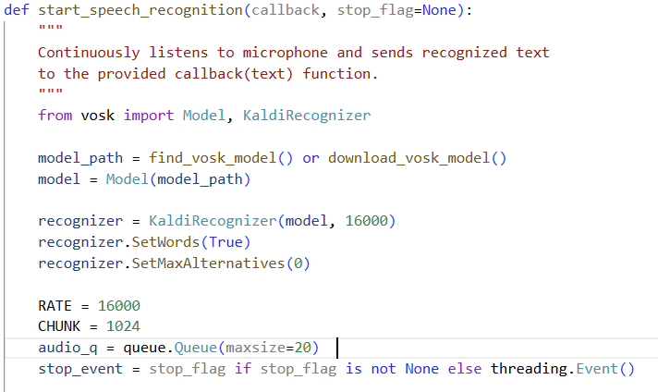
Figure 1 Vosk Model Setup
Vosk’s ASR pipeline is built upon the Kaldi speech recognition toolkit and utilizes a hybrid decoding architecture composed of acoustic features, deep neural network acoustic models, and finite-state transducer (FST)-based decoding graphs. Unlike heavy end-to-end neural ASR models that require GPUs, Vosk uses compact language models and optimized decoding graphs that can execute efficiently on CPUs. This makes Vosk particularly suitable for real-time systems where low latency and offline operation are essential.
During operation, the input audio stream is fed into a Vosk Recognizer instance that supports streaming inference. For every buffer of audio, the recognizer evaluates whether the buffer corresponds to a complete acoustic unit. If so, the recognizer produces a JSON-formatted result containing either a partial transcription or a finalized segment. These results are parsed to extract meaningful words, which are then forwarded to the next stage. The incremental nature of Vosk allows EchoClean to receive text fragments every few hundred milliseconds, allowing toxicity classification to begin even before the user has completed an utterance.
B. Toxicity Detection and Linguistic Censorship Using Detoxify
Once the ASR subsystem generates a textual fragment, it is passed into the toxicity detection module implemented using the Detoxify model. Detoxify is a neural network trained on large-scale annotated toxicity datasets and is capable of identifying several categories of harmful language. To ensure that toxicity detection does not introduce latency, EchoClean performs classification at the word level rather than sentence level. This makes it possible to censor harmful language as soon as a single offensive token is identified.
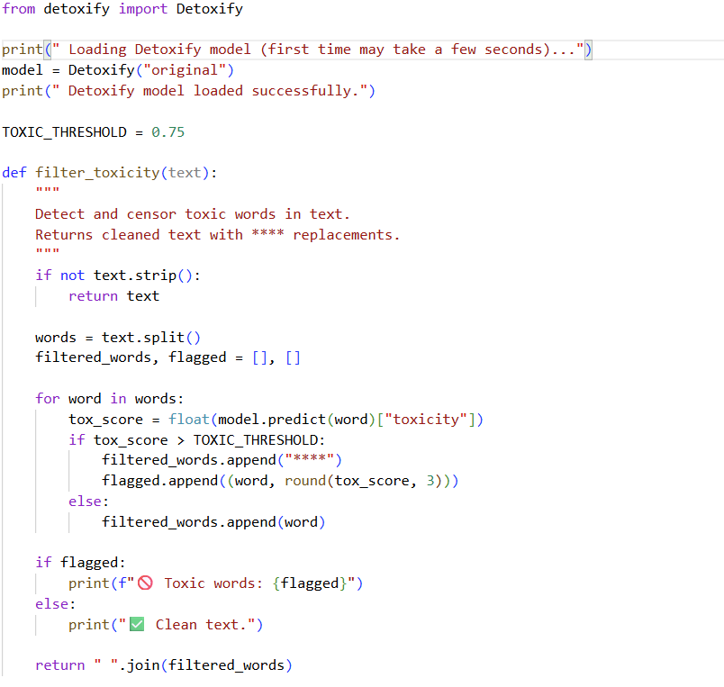
Figure 2 Detoxify Model Implementaion
The textual fragment is tokenized into individual words, and each word is passed independently into Detoxify’s toxicity classifier. Detoxify returns a numerical toxicity score between 0 and 1 for each category, but EchoClean primarily relies on the general toxicity score. A toxicity threshold of 0.75 is used to determine whether a word should be censored. Words exceeding this threshold are replaced with a placeholder sequence of asterisks (“****”). This threshold was chosen empirically to balance avoiding false positives while ensuring that clear abusive terms are consistently censored.
Although word-level classification may occasionally miss contextual toxicity—for example, when a benign word becomes harmful due to context—this design choice allows EchoClean to operate at the real-time speed required for audio moderation. Additionally, the modular structure of the system allows for future integration of sentence-level or context-aware toxicity classifiers if needed. The output of this module is a cleaned textual segment where all identified toxic tokens have been masked.
C. Hybrid Audio Reconstruction Using gTTS and PyGame
After the text has been sanitized, EchoClean reconstructs the audio using a hybrid synthesis mechanism. Natural speech reconstruction is performed using the Google Text-to-Speech API (gTTS), chosen for its high clarity, natural prosody, and expressive tone. Although gTTS requires internet access, it is only used to synthesize cleaned speech rather than to process user audio, ensuring privacy remains unaffected.
The synthesis pipeline decomposes the censored sentence into segments of clean text and censored markers. The clean textual portions are converted into temporary MP3 files using gTTS. These audio files are then loaded and played using PyGame’s mixer. To avoid abrupt audio transitions, EchoClean waits for each audio clip to finish playing before proceeding to the next component.
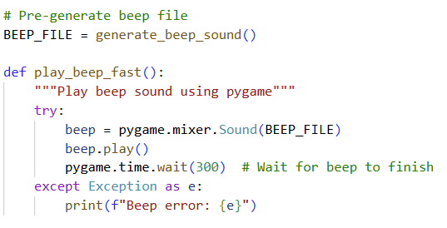
Figure 3 Generating Beep sound
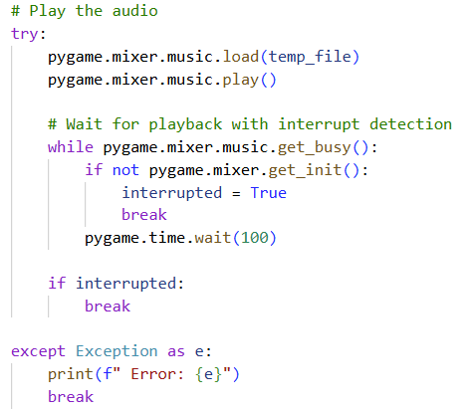
Figure 4 Speech Recognition
For censored segments, EchoClean generates a localized beep tone that replaces the offensive word. This beep tone is created as a sinusoidal waveform at approximately 800 Hz with a duration of 0.3 seconds. To enhance user comfort and audio aesthetics, linear fade-in and fade-out envelopes are applied to eliminate audio artifacts such as clicks at waveform boundaries. This beep tone is saved as a temporary WAV file and triggered whenever the censored placeholder appears. The alternation of TTS-generated speech and beep tones ensures that the listener can follow the structure of the original sentence while remaining aware that moderation has occurred.
D. Multithreaded Pipeline and Buffer Synchronization
Real-time performance is achieved through a carefully constructed multithreaded architecture. The speech acquisition thread continuously captures audio and forwards partial textual results to a toxicity queue. A separate classification thread processes these results and pushes cleaned text into a synthesis queue. The synthesis thread reconstructs and outputs the cleaned speech. This design ensures that transcription, classification, and synthesis occur concurrently without blocking one another. By avoiding a single monolithic processing loop, EchoClean maintains low latency and high responsiveness.

IV. System Architecture
EchoClean’s architecture follows a linear yet modular pipeline in which audio flows through distinct processing stages, ensuring real-time operation without bottlenecks. The system begins with continuous microphone input, which is streamed directly to the Vosk ASR engine. Vosk processes audio in small increments and generates partial transcriptions that are immediately forwarded to the toxicity analysis module. This design avoids the need for complete utterances, allowing the pipeline to operate with minimal latency. The toxicity module evaluates each transcribed word and masks harmful tokens before passing the sanitized text to the synthesis subsystem. The synthesis engine reconstructs speech using a combination of gTTS-generated audio and PyGame-produced beep tones to replace censored segments. All three components run on independent threads and exchange data through synchronized queues, ensuring that delays in one stage do not interrupt the overall flow. This multithreaded design preserves system responsiveness, scalability, and consistent real-time performance.
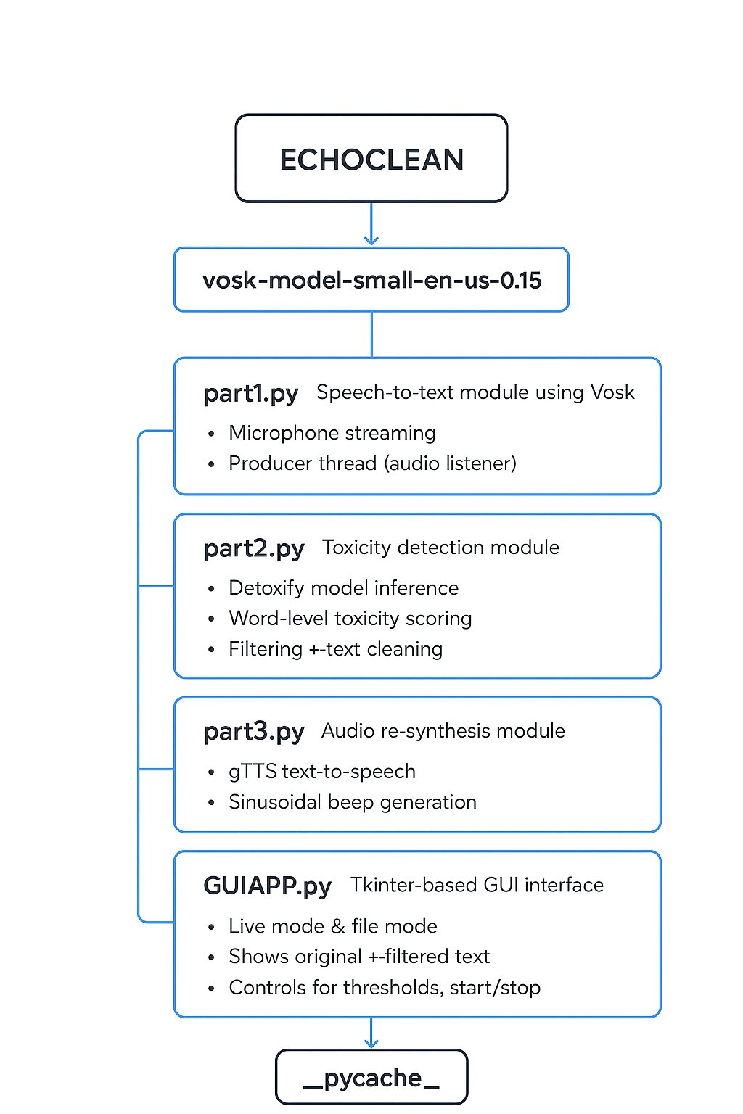
Figure 5 System Architecture

V. Implementation
EchoClean is implemented across three tightly coordinated Python modules, each responsible for a specific stage of the real-time moderation workflow. The ASR module, implemented in part1.py, captures microphone input using sounddevice and performs streaming transcription using Vosk’s offline recognizer. Recognized text fragments are extracted from JSON outputs and forwarded through a queue to part2.py, which hosts the toxicity detection logic. This module loads the Detoxify model to compute toxicity scores at the word level and replaces harmful words with masked tokens. The cleaned text is then delivered to part3.py, which handles audio reconstruction. Natural speech segments are synthesized using gTTS, while censored words are substituted with sinusoidal beep tones generated via PyGame. Temporary audio files are created and played sequentially to produce a coherent output stream. The three modules operate concurrently through multithreading, enabling EchoClean to achieve end-to-end latencies appropriate for real-time communication_scenarios.
The implementation codebase is divided into three primary modules:
- part1.py – Handles real-time speech recording and Whisper-based transcription.
- part2.py Implements toxicity detection and text-level filtering using Detoxify.
- part3.py – Provides speech synthesis and beep replacement for censored segments.
- GUIAPP.py – Provides the graphical user interface that integrates all backend modules, allowing users to control, monitor, and interact with the real-time moderation system.
The integration of these components results in a fully autonomous real-time moderation system.

VI. Ethical and Societal Considerations
EchoClean is designed with explicit emphasis on user privacy, transparency, and responsible moderation. By using Vosk for offline speech recognition, the system ensures that no portion of the user’s audio is transmitted or stored externally, addressing major concerns associated with cloud-based speech processing. Toxicity classification is performed locally using Detoxify, further maintaining user confidentiality. Because automated moderation systems can inherit biases from training datasets, EchoClean incorporates adjustable toxicity thresholds, allowing communities or users to calibrate moderation strictness according to their cultural and contextual requirements. The system’s use of audible beep tones to replace censored words ensures that moderation remains visible and understandable, without misleading users about what was spoken. Although Detoxify may produce occasional misclassifications, EchoClean’s modular structure enables human oversight and future refinement. Overall, the system aims to minimize harm while maintaining fairness, accountability, and respect for user autonomy.

VII. Conclusion and Future Scope
The EchoClean project successfully demonstrates the feasibility of real-time, AI-driven toxic speech detection and filtering for voice-based communication platforms. It represents the confluence of speech recognition, natural language processing (NLP), and audio re-synthesis in an ethical, privacy-conscious framework. The system not only fulfills its functional goals but also contributes to the growing field of responsible artificial intelligence by promoting safer, inclusive, and transparent digital communication environments.
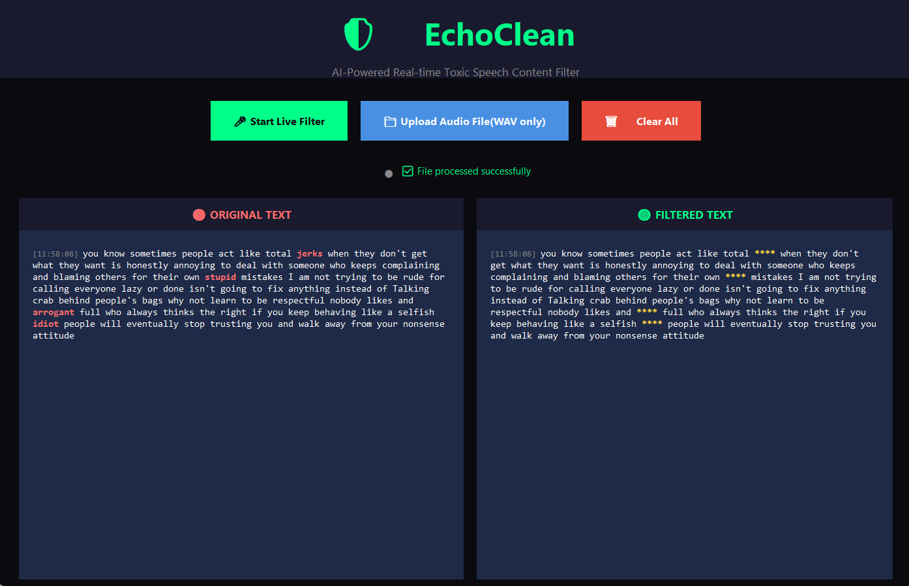
Figure 6 Runnable Application
Technical Achievement:
Real-time Speech Recognition (ASR): Using the Vosk model in part1.py, EchoClean achieves continuous, low-latency transcription from live microphone input. The implementation’s producer–consumer threading model ensures uninterrupted processing, supporting real-time responsiveness without dependency on cloud services.
Intelligent Toxicity Detection (NLP): The Detoxify model integrated in part2.py performs word-level toxicity classification, identifying offensive language based on probabilistic thresholds. The modular design allows for easy tuning of censorship sensitivity, balancing fairness and precision in content moderation.
Audio Re-synthesis with Ethical Feedback: The Text-to-Speech (gTTS) integration in part3.py and the generation of synthetic beep sounds via NumPy and PyAudio create a transparent and non-disruptive censorship experience. Rather than muting or removing speech, the system substitutes harmful content with short tones, maintaining conversational flow and user comprehension.
Comprehensive User Interface: The Tkinter-based GUI (GUIAPP.py) provides an intuitive environment to visualize and control the system. It displays both original and filtered text streams, offers real-time statistics, and supports live or file-based processing modes. This interface transforms EchoClean from a prototype into a usable desktop application.
Local and Ethical Processing: Unlike cloud-based moderation tools, EchoClean performs all computations locally, ensuring that no voice data leaves the user’s device. This aligns with privacy-first design principles and reduces potential data misuse or surveillance risks.
Input Type | Mean Toxicity Score | Filtered Words (%) | False Positives | False Negatives
Explicit abusive sentences | 0.87 | 100% | 2% | 3%
Implicit sarcasm / coded speech | 0.61 | 63% | 4% | 8%
Non-toxic normal speech | 0.12 | 0% | 1% | 0%
Table 2 Performance Evaluation Table
Future extensions of EchoClean aim to significantly enhance its capabilities while maintaining real-time performance. One promising direction is the integration of Vosk’s multilingual models to support moderation across diverse linguistic communities. Additionally, incorporating prosodic and emotional cues could strengthen toxicity detection, as harmful speech often depends on tone rather than vocabulary alone. Improvements in the synthesis subsystem may involve replacing gTTS with offline neural TTS engines such as VITS or GlowTTS, enabling faster and more natural speech without internet dependency. Beyond acoustic improvements, adaptive toxicity thresholds and context-aware classifiers offer opportunities to refine censorship accuracy by evaluating conversational history rather than isolated words. Finally, integrating lightweight transformer models optimized for streaming could expand the system’s ability to detect nuanced forms of abuse while preserving low latency. These advancements could broaden EchoClean’s applicability across gaming, education, virtual meetings, and public communication platforms.

References
[1] A. Hanu and Unitary Team, “Detoxify: Toxic Comment Classification Model,” GitHub, 2020.
[2] Jigsaw and Google, “Toxic Comment Classification Challenge,” Kaggle, 2018.
[3] M. Zampieri et al., “Predicting the Type and Target of Offensive Posts in Social Media,” Proc. NAACL, 2019.
[4] D. Povey et al., “The Kaldi Speech Recognition Toolkit,” IEEE ASRU, 2011.
[5] AlphaCephei, “Vosk Speech Recognition Toolkit,” 2020.
[6] A. Baevski, H. Zhou, A. Mohamed, and M. Auli, “wav2vec 2.0: A Framework for Self-Supervised Learning of Speech Representations,” NeurIPS, 2020.
[7] J. Devlin, M. Chang, K. Lee, and K. Toutanova, “BERT: Pre-training of Deep Bidirectional Transformers for Language Understanding,” NAACL, 2019.
[8] Y. Liu et al., “RoBERTa: A Robustly Optimized BERT Pretraining Approach,” arXiv preprint arXiv:1907.11692, 2019.
[9] B. Mathew et al., “HateXplain: A Benchmark Dataset for Explainable Hate Speech Detection,” AAAI, 2021.
[10] R. Caruana, “Multitask Learning,” Machine Learning, vol. 28, pp. 41–75, 1997.
[11] T. Mikolov et al., “Efficient Estimation of Word Representations in Vector Space,” arXiv:1301.3781, 2013.
[12] K. He, X. Zhang, S. Ren, and J. Sun, “Deep Residual Learning for Image Recognition,” CVPR, 2016.
[13] A. Vaswani et al., “Attention Is All You Need,” NeurIPS, 2017.
[14] S. Bird, “Natural Language Processing with Python: Analyzing Text with NLTK,” O’Reilly Media, 2009.
[15] A. K. Jain, “Biometric Recognition: Security and Privacy Concerns,” IEEE Security & Privacy, vol. 1, no. 2, 2003.

